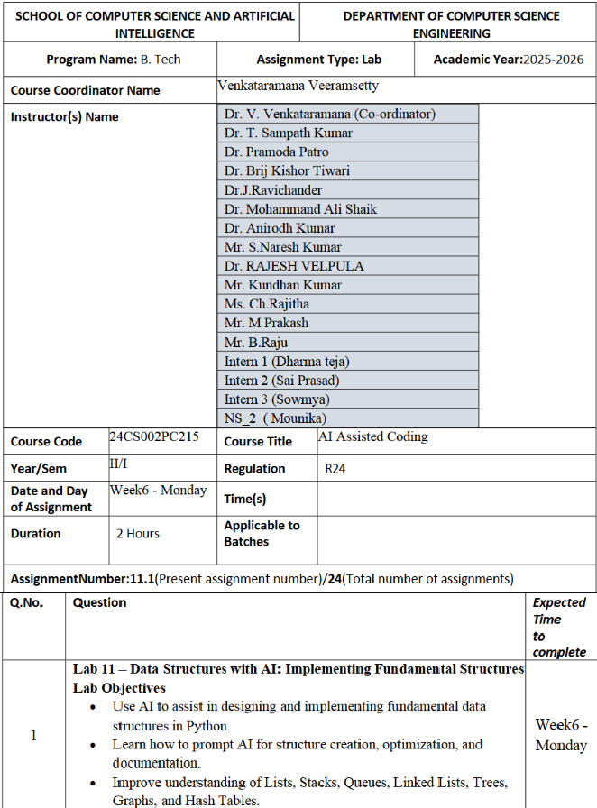

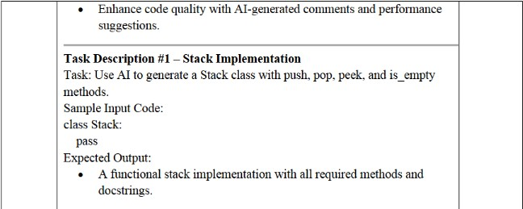

**Prompt :**

Create a Python class named Stack with methods: push, pop, peek, and is_empty with user input

**Code:**

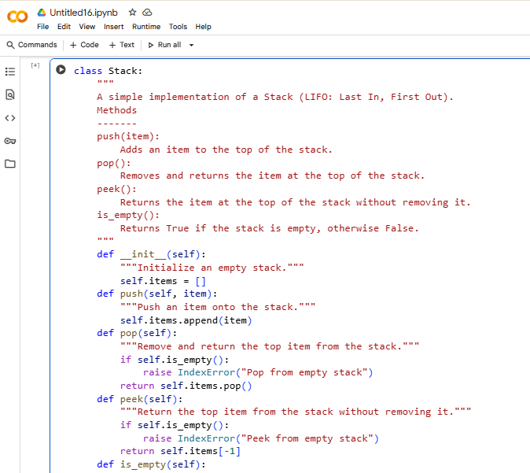

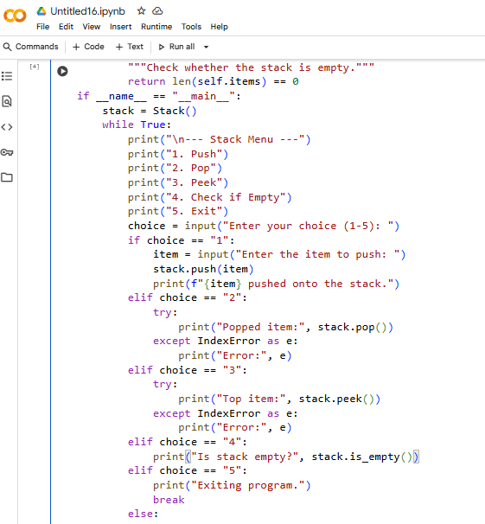

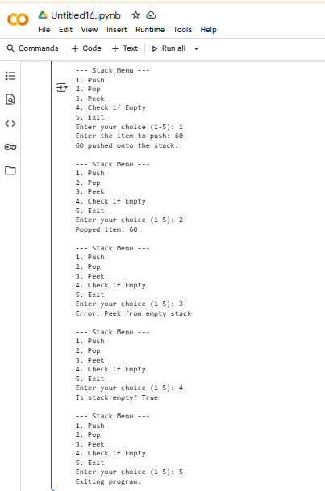

**observations and code expalnation**

 Defined Stack class with a list to store elements.

 push(item) → adds an element to the top of stack.

 pop() → removes and returns the top element; handles empty stack.

 peek() → shows top element without removing it.

 is_empty() → checks if stack is empty.

 Interactive code asks for number of elements → pushes elements from user input.

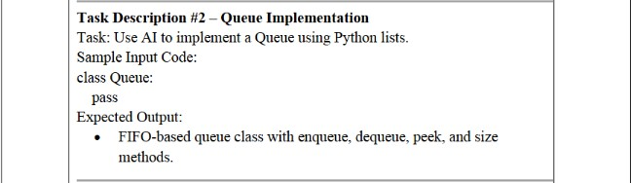

**prompt :**

Create a Python class named Queue using list. Include methods: enqueue, dequeue, peek, and size with user input.

**code:**

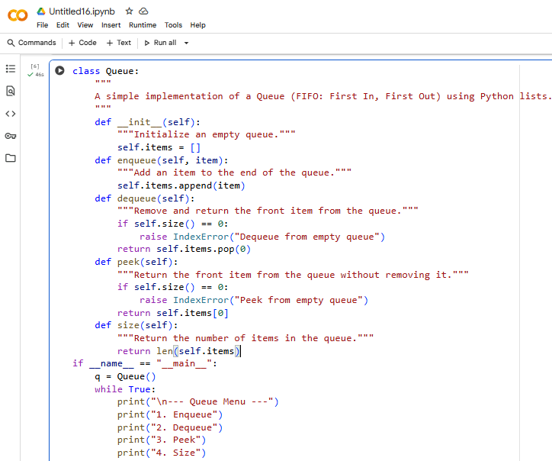

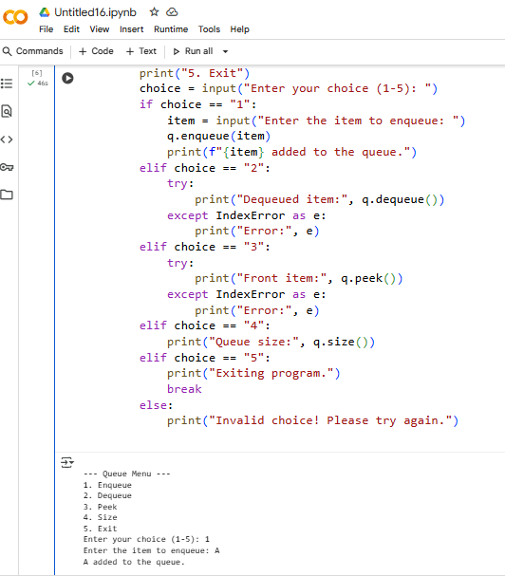

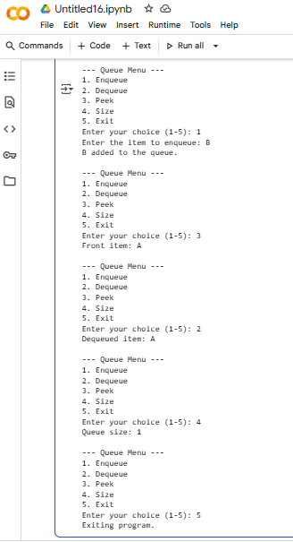

**observations and code expalnation :**

 Queue class stores elements in a list.

 enqueue(item) → adds element at the rear.

 dequeue() → removes element from front; prints message if empty.

 peek() → shows front element.

 size() → returns number of elements.

 User input used to enqueue multiple elements; then displays front and dequeued element.

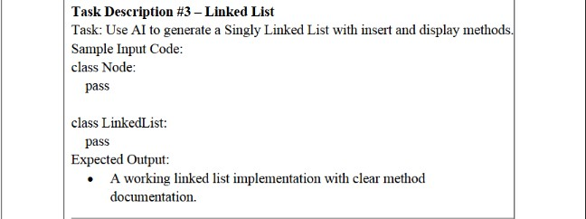

**Prompt :**

Create a Python Singly Linked List with Node class. Include insert and display methods with user input.

**Code:**

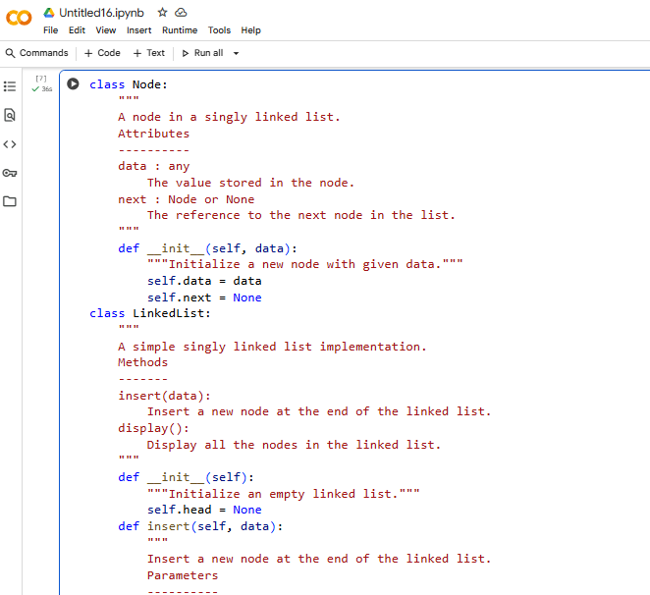

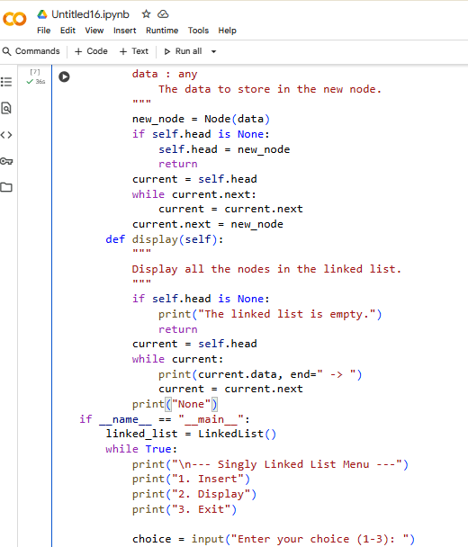

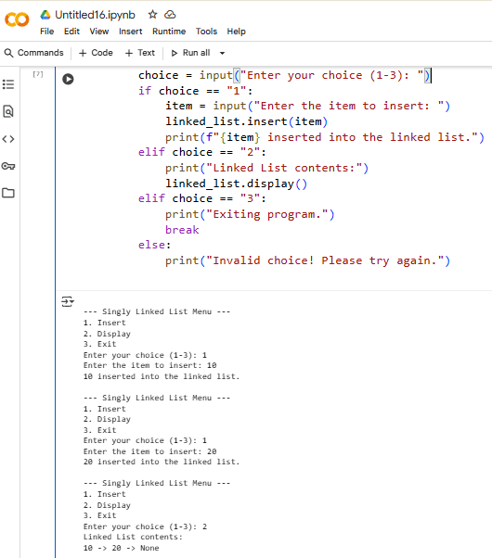

**Code explanation and observations :**

 Node class stores data and next pointer.

 LinkedList class has head pointer.

 insert(data) → adds new node at end.

 display() → prints all nodes in order.

 User inputs number of nodes → program inserts each one and displays list.

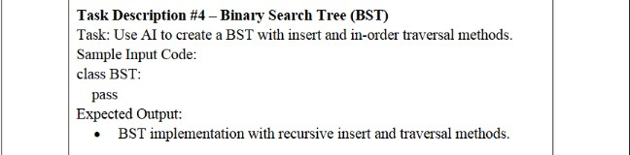

**Prompt :**

Create a Python BST class with insert and inorder traversal methods. Make it interactive for user input.

**Code :**

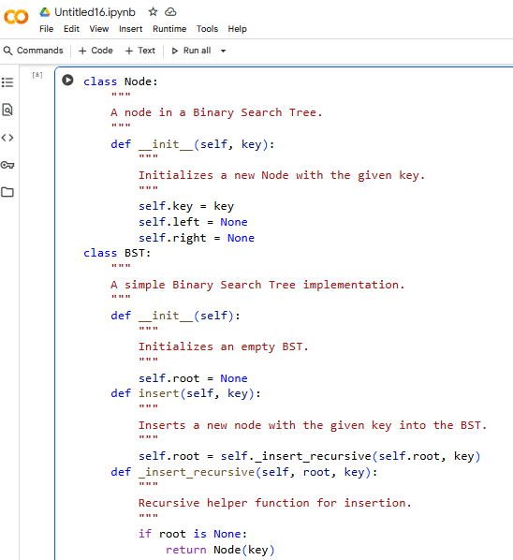

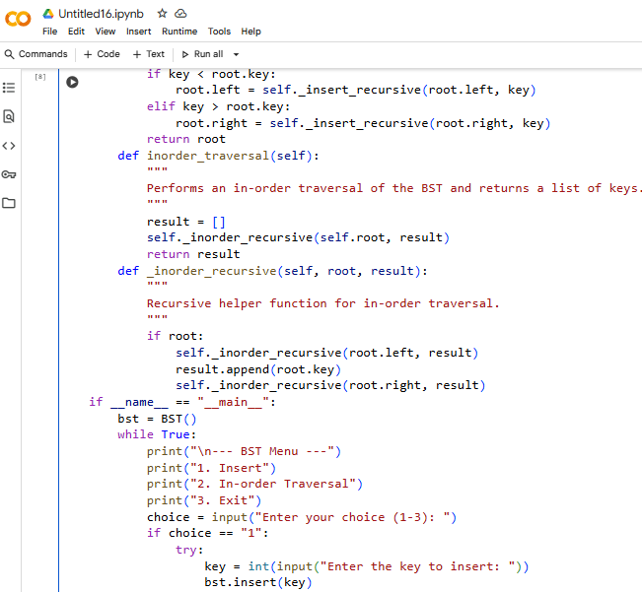

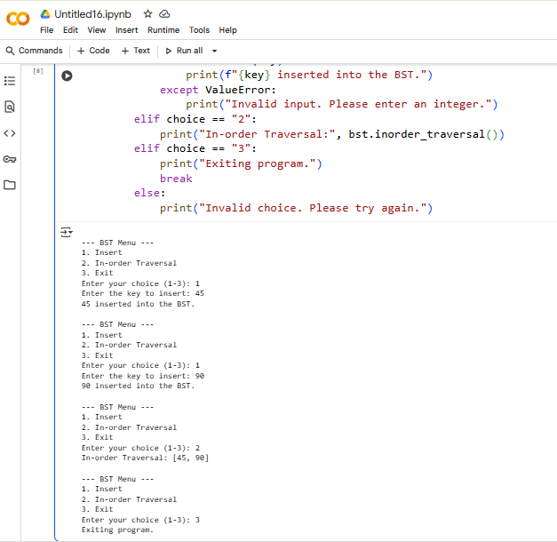

**observations and code expalnation**

BST node has data, left, right.

insert(data) → recursively places node in correct position. inorder() → returns elements in sorted order.

Program asks for root, then number of elements → inserts each. Prints inorder traversal to verify BST structure.

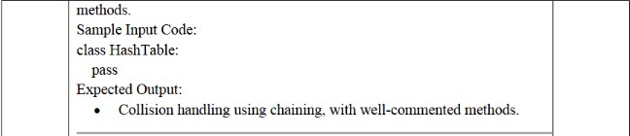

**Prompts** :

Create a Python Hash Table class with insert, search, and delete methods. Handle collisions using chaining with user input.

**Code:**

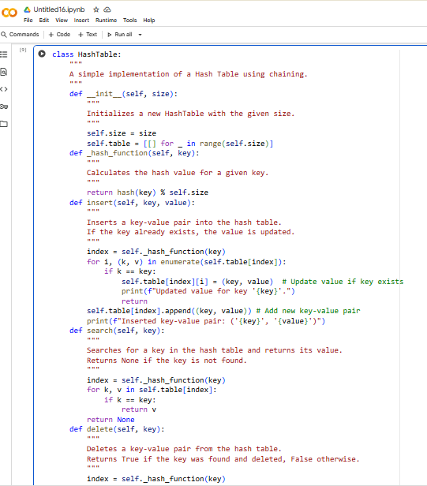

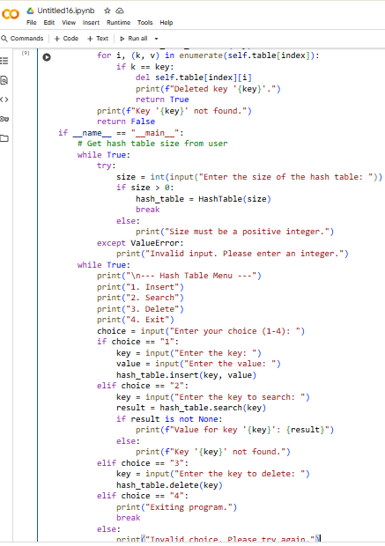

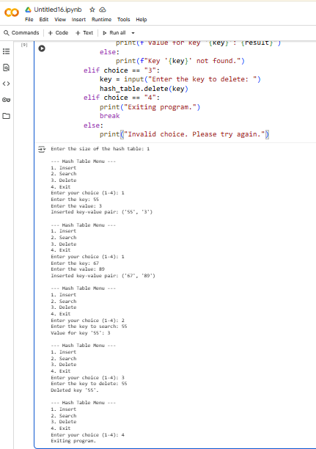

**Observation and code explanation**

Uses a list of lists (buckets) for collision chaining. insert(key, value) → hashes key → appends to bucket.

search(key) → looks for key in bucket → returns value or None. delete(key) → removes key-value pair if exists.

User enters number of key-value pairs → program inserts → searches and prints result.

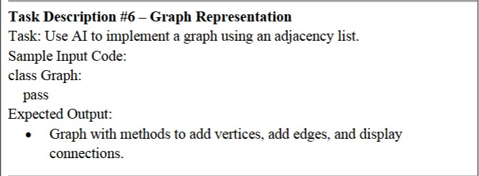

**Prompt :**

Create a Python Graph class using adjacency list. Include methods: add_vertex, add_edge, display with user input

**Code:**

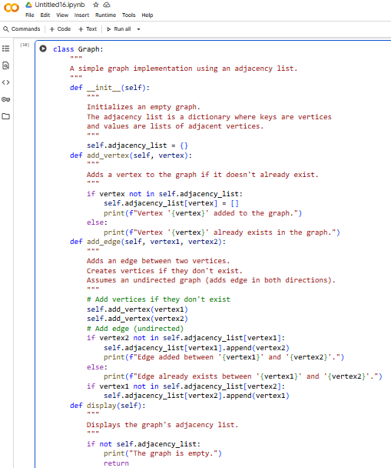

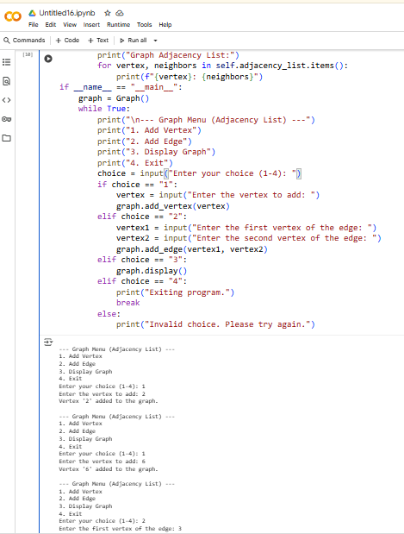

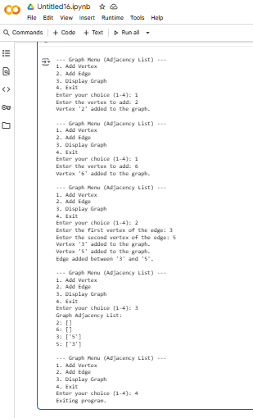

**Code explanation and Observation :**

 Dictionary stores adjacency list.

 add_vertex(v) → adds vertex if not exist.

 add_edge(v1, v2) → adds edge (undirected) between two vertices.

 display() → prints adjacency list.

 Program asks number of vertices and edges → user enters each → displays graph.

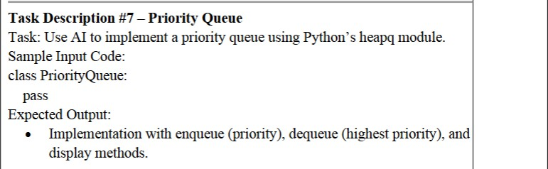

**Prompt :**

Create a Python Priority Queue class using heapq. Include enqueue (priority), dequeue (highest priority), and display methods. With user input.

**Code :**

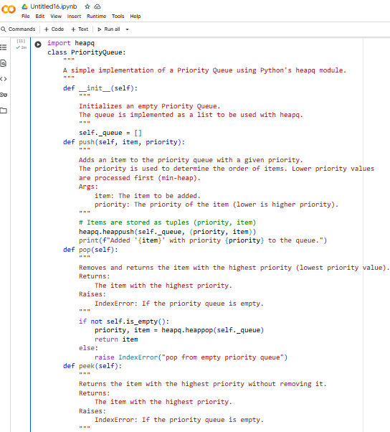

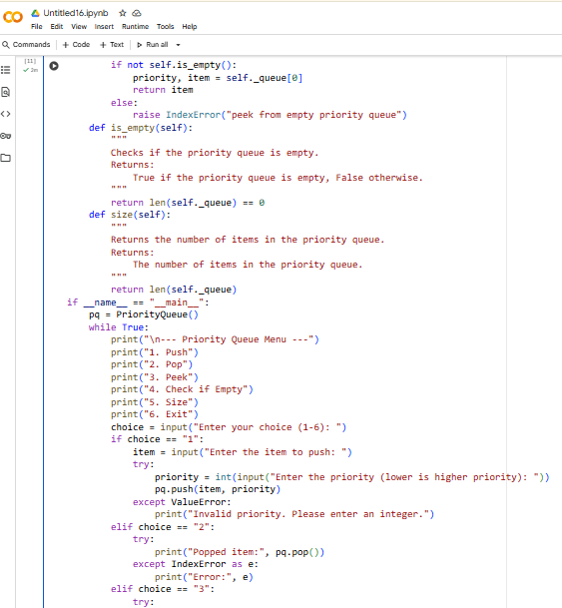

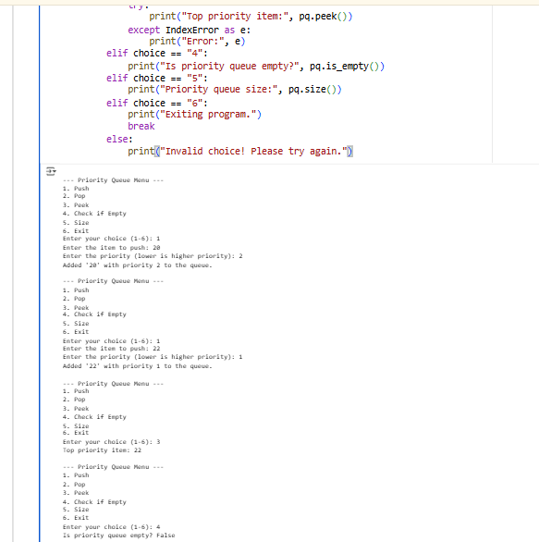

**Observation and code explanation:**

Uses heapq for priority management. enqueue(priority, item) → pushes tuple (priority, item). dequeue() → pops element with smallest priority value. display() → shows queue.

User enters items with priority → program enqueues → dequeues highest priority → displays queue.

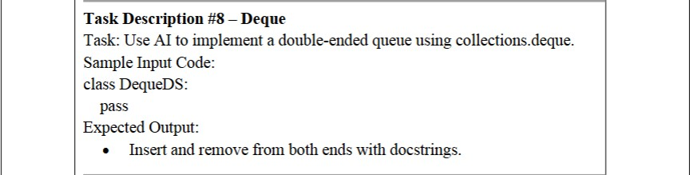

**Prompt :**

Create a Python Deque class using collections.deque. Include methods: insert_front, insert_rear, remove_front, remove_rear, display. Interactive input.

**Code :**

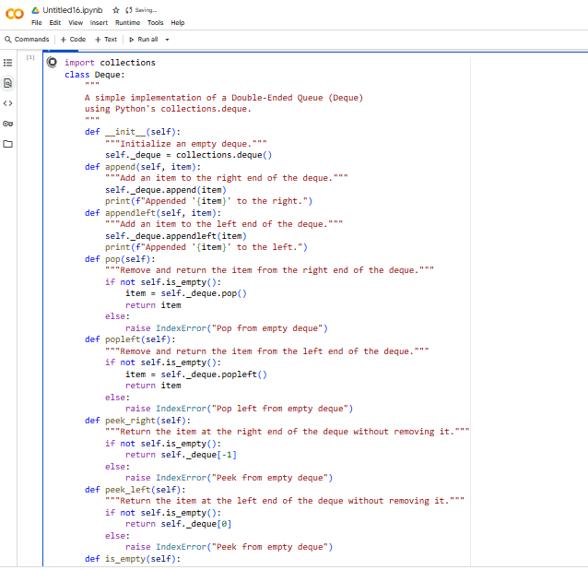

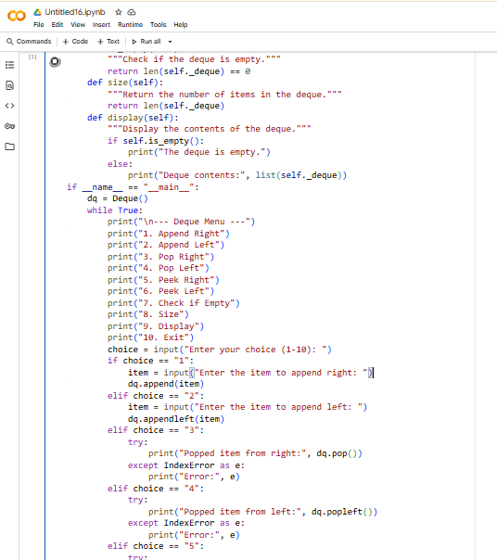

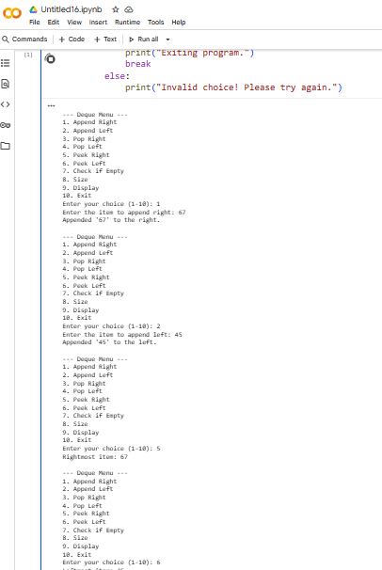

**Observation and code explation**

 collections.deque allows fast insertion/removal at both ends.

 insert_front(item) → adds to front.

 insert_rear(item) → adds to rear.

 remove_front() / remove_rear() → removes from respective end.

 display() → prints deque.

 User inputs number of elements → inserts → removes → displays deque.

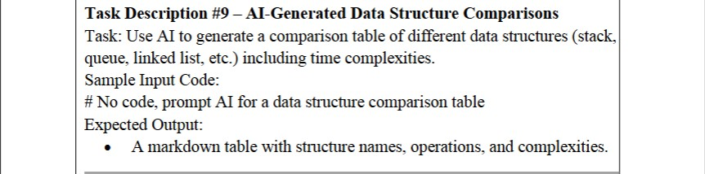

**Prompt :**

Generate a python code for comparison table of different data structures (stack,queue,linked list).

**Table :**

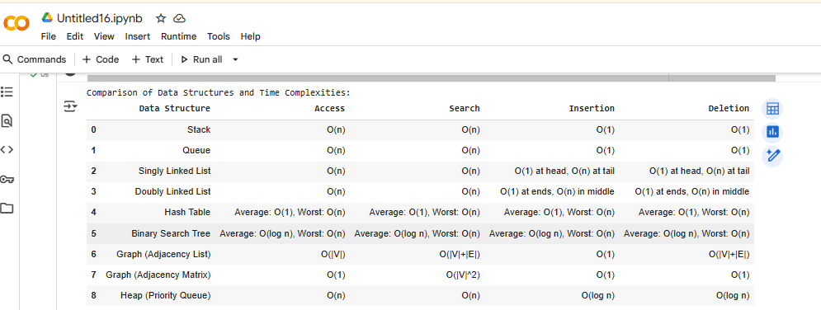

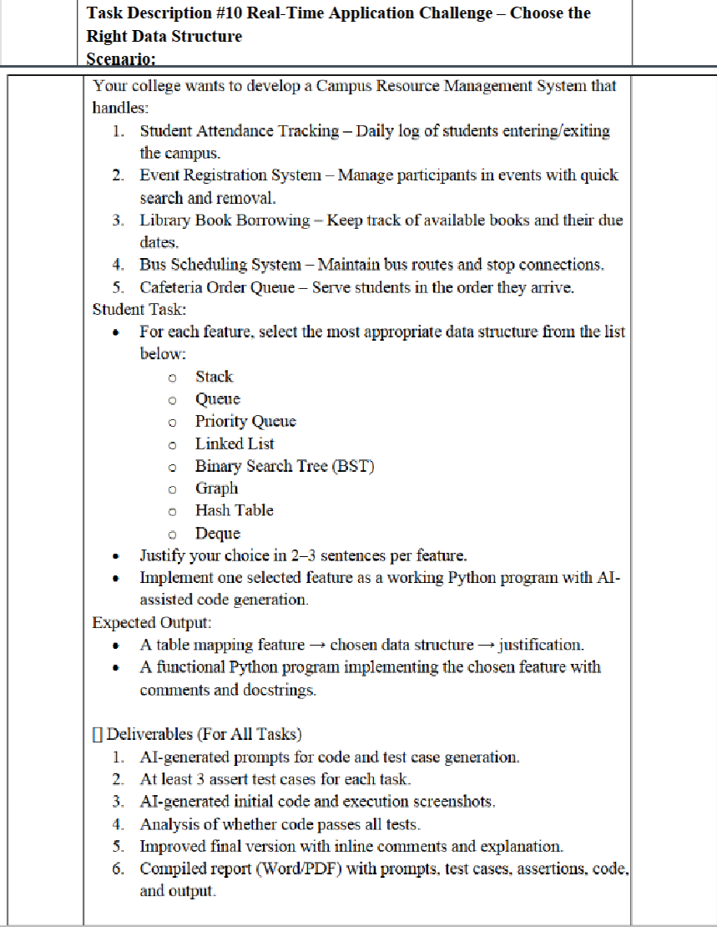

**Prompt :**

Create a Python menu-driven Queue for cafeteria orders. Include methods: place_order, serve_order, next_order, queue_size. Use user input to interact.

**Code:**

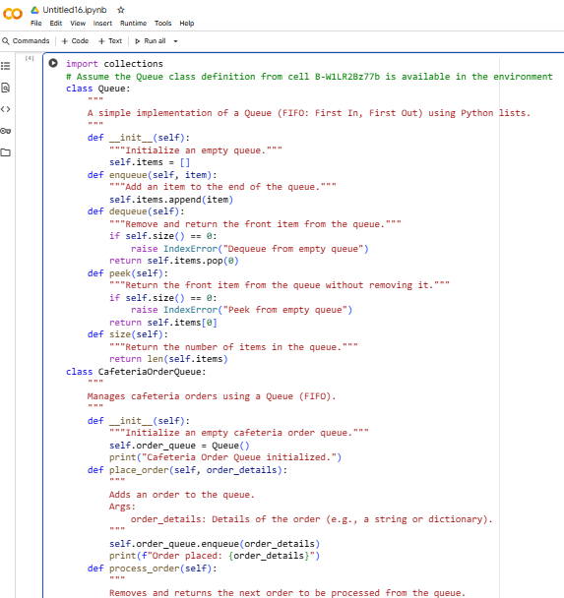

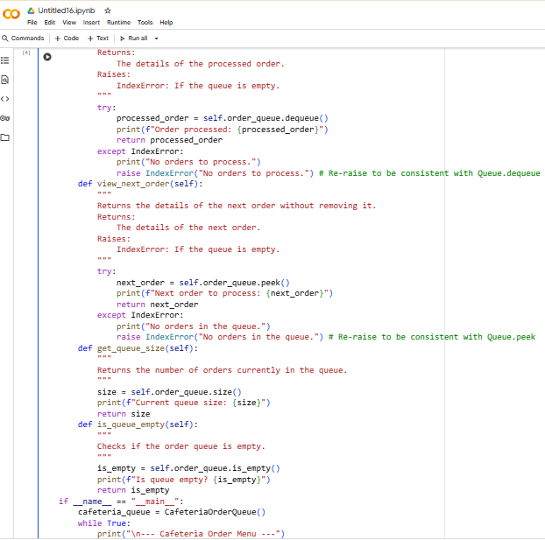

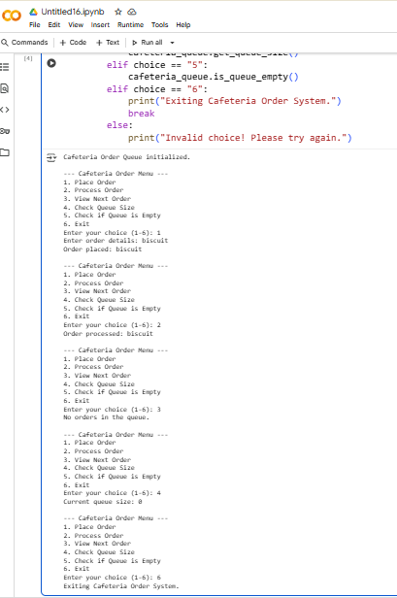

**Observations and Code Explanation:**

CafeteriaOrderQueue uses circular queue array.

place_order(student_name) → adds student; handles full queue. serve_order() → serves front student; handles empty queue. next_order() → shows next order without removing. queue_size() → displays number of orders.

Menu allows user to place, serve, peek, check size, exit interactively.